COMMUNITY SKILL SWAP HUB
@CREATIVITY THINK (9483175986/7019689991)

ABSTRACT:
Community Skill Swap Hub is a web-based platform designed to connect individuals within local communities, colleges, and hobby groups to exchange skills through scheduled sessions. The system allows users to create skill profiles, request swaps, communicate via chat, schedule sessions, provide ratings, and track session history through an interactive dashboard. Administrators can verify users and locations, moderate skill listings, monitor chats and reports, manage categories, and export analytics for operational insights. Developed with Django and Django Rest Framework for backend operations, and React with Redux and Socket.io for frontend interactivity and real-time chat, the platform ensures secure, organized, and efficient skill exchange within communities..

INTRODUCTION OF THE PROJECT:
Traditional methods of skill exchange rely heavily on informal networks, making it difficult to find suitable participants, schedule sessions, or maintain a history of exchanges. Community Skill Swap Hub addresses these challenges by providing a centralized digital platform that facilitates skill sharing, enables communication between users, tracks completed sessions, and offers analytics for administrators. By structuring the process of skill swaps and providing user verification and ratings, the system encourages trust, accountability, and active participation..

PROJECT OBJECTIVES:

• Enable users to register and create skill profiles (skills they can teach or want to learn)
• Allow users to browse nearby skills and send/accept swap requests
• Support real-time chat for scheduling and discussion
• Track session completion, provide rating and feedback, and maintain history dashboards
• Allow administrators to verify users and locations, approve or flag skill listings, and monitor chats
• Manage skill categories, tags, and system analytics
• Export usage and performance reports for administrative review
• Provide a scalable and secure platform for community-based skill sharing

PROBLEM OF THE STATEMENT:
Skill-sharing initiatives are often limited by poor visibility, lack of organized scheduling, and absence of reliable communication channels. Participants may struggle to find appropriate matches, track past sessions, or rate experiences. Administrators lack the tools to monitor activity, validate participants, or extract useful insights. Community Skill Swap Hub solves these issues by providing a secure, structured, and analytics-driven platform for skill exchanges, enhancing community engagement and trust..

MOTIVATION OF THE PROJECT:
• To provide a structured platform for community skill exchange
• To facilitate secure and transparent scheduling of skill sessions
• To improve communication and coordination among users
• To encourage accountability through ratings, feedback, and session history
• To provide administrators with oversight and analytics for informed decision-making
• To promote continuous learning and skill sharing in local communities
• To enable real-time interaction and easy management of skill swaps

BLOCK DAIGRAM OF PROJECT:

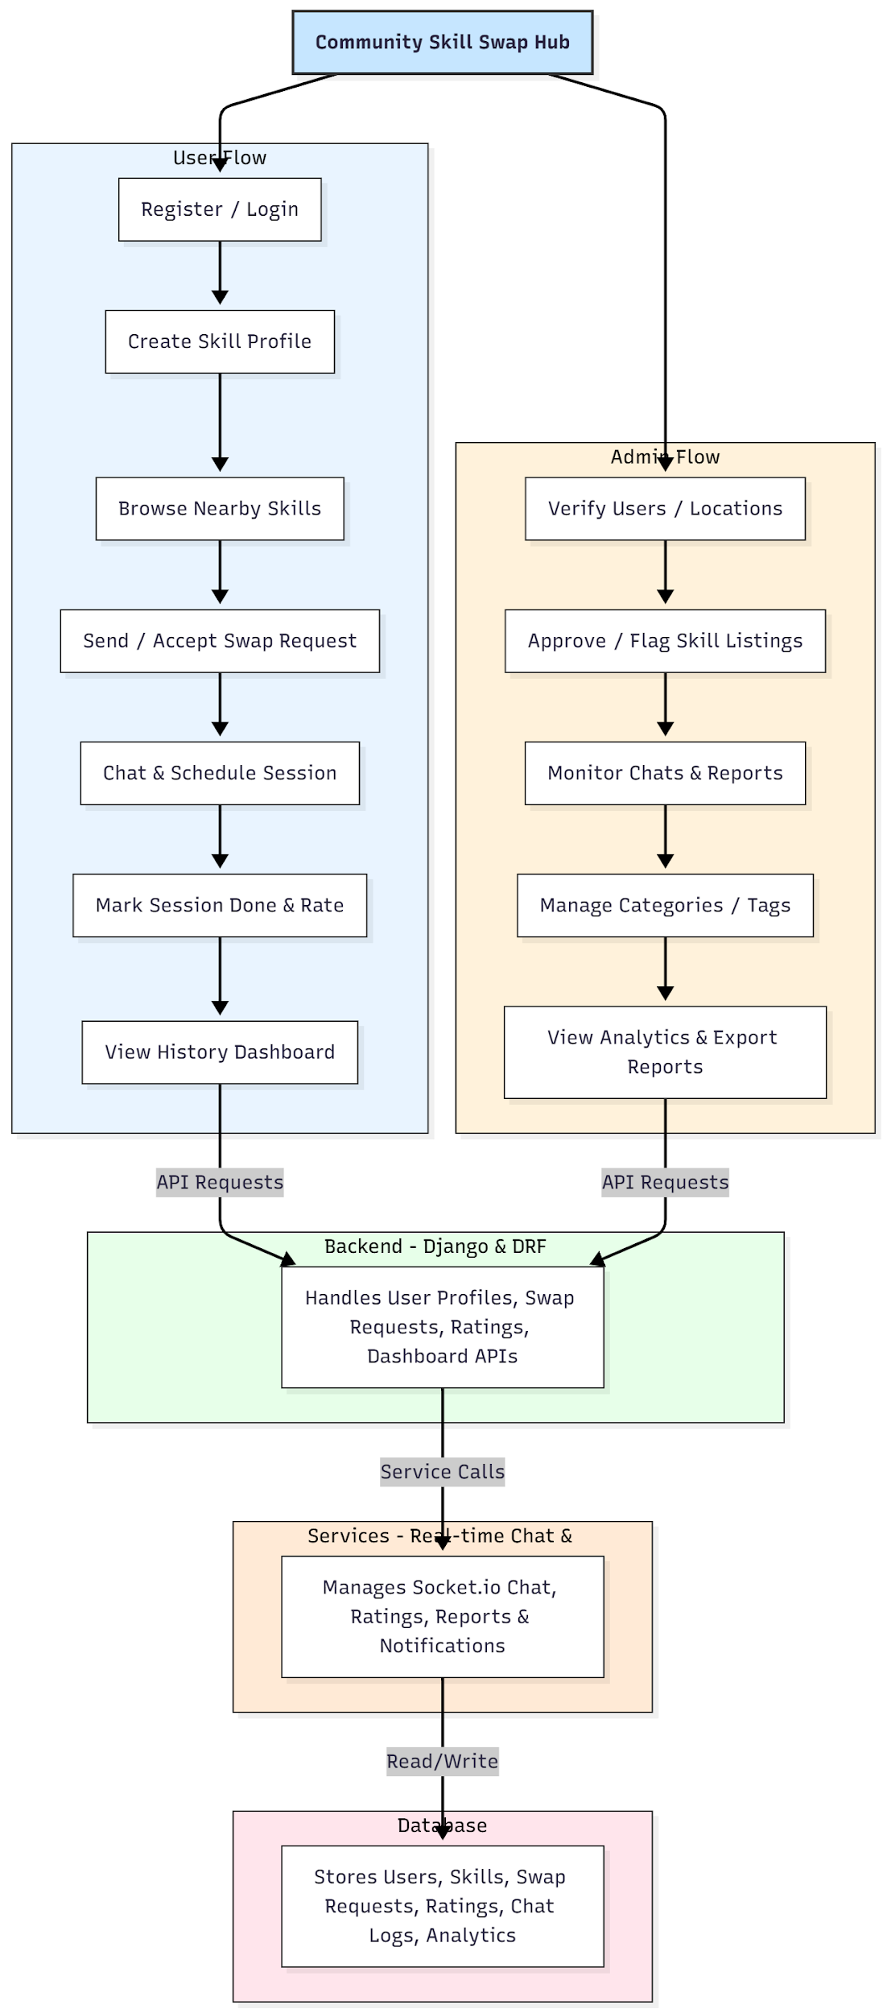

WORKING OF THE PROJECT:
Users register and create their skill profiles, specifying what they can teach or wish to learn. They browse available nearby skills and send swap requests. Upon acceptance, users communicate via real-time chat to schedule sessions. After completion, sessions are marked done, and participants provide ratings and feedback. The history dashboard allows users to review past swaps. Administrators verify users, approve listings, monitor chats, manage categories and tags, and generate analytics reports. The backend and services handle API requests, chat communications, ratings, and database interactions to ensure smooth and secure operations..

SOFTWARE REQUIREMENT:
- Backend:
  - Python 3.x
  - Django
  - Django REST Framework
  - SQLite/PostgreSQL
- Frontend:
  - Node.js and npm
  - React.js
  - Axios
- Development Tools:
  - Visual Studio Code
  - Postman (for testing APIs)
  - Git/GitHub (for version control)
- Server/Deployment (Optional):
  - Gunicorn, Nginx, or Heroku/AWS for hosting

ADVANTAGES OF THE PROJECT:

• Facilitates community-based skill exchange
• Real-time chat and scheduling capabilities
• User verification and rating for trust-building
• Dashboard analytics for users and administrators
• Structured and organized skill management
• Scalable backend and responsive frontend
• Supports exportable reports for analysis
• Encourages learning, collaboration, and social engagement

APPLICATIONS OF THE PROJECT:
• Local community skill-sharing networks
• College clubs and hobby groups
• Volunteer organizations
• Professional skill exchange programs
• Peer-to-peer mentoring and coaching
• Workshop and learning session coordination

REFERENCES:

- Django REST Framework Documentation — Django Software Foundation. Django Documentation. Available: https://docs.djangoproject.com/
- Django REST Framework. DRF Documentation. Available: https://www.django-rest-framework.org/
- React. React Official Documentation. Available: https://reactjs.org/docs/getting-started.html
- Redux. Redux Documentation. Available: https://redux.js.org/introduction/getting-started
- PostgreSQL Global Development Group. PostgreSQL Documentation. Available: https://www.postgresql.org/docs/
- MySQL. MySQL Reference Manual. Available: https://dev.mysql.com/doc/
- Git. Git Documentation. Available: https://git-scm.com/doc
- Node.js. Node.js Documentation. Available: https://nodejs.org/en/docs/
- Axios. Axios Documentation. Available: https://axios-http.com/docs/intro
- Socket.io Documentation – https://socket.io/docs/

